**AFIQ FAHMI BIN ROSLAN**

**A21EC0153**

**Lab Exercise 5.0**

1. Basic Navigation

1. Path navigation using absolute path

1. Path navigation using relative path.

1. Shortcut absolute path

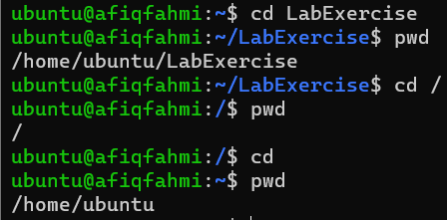

1. Changing permission with symbolic notation

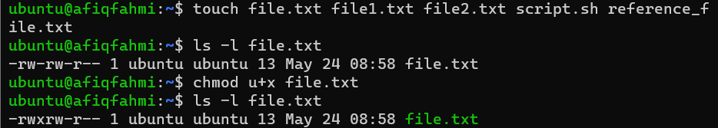

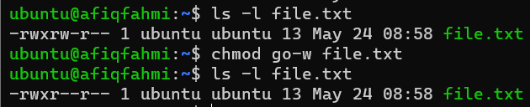

1. Changing Permission with Octal Notation

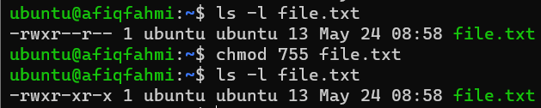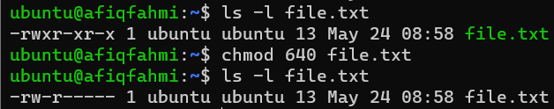

1. Changing Permissions with Reference File:
   1. A picture containing text, screenshot, font

      Description automatically generated
2. Changing Permissions for Multiple Files:
   1. 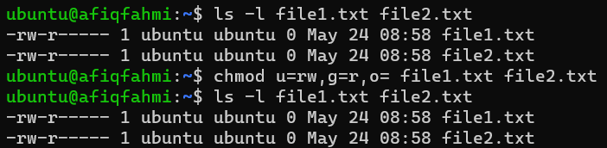
   2. 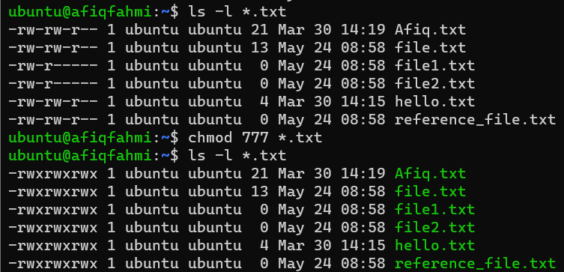
3. Changing Permissions Recursively for Directories:
   1. 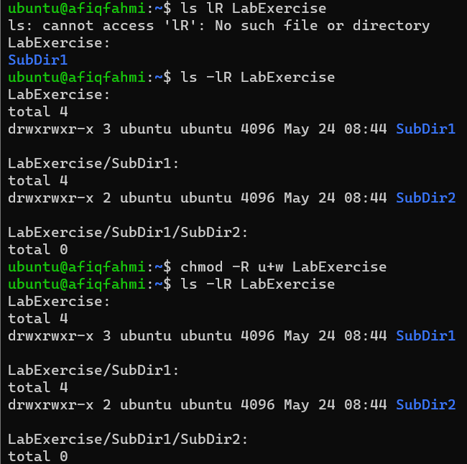
4. Changing Permissions with Special Modes:
   1. 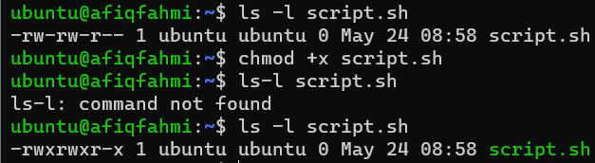
   2. A black screen with white text

      Description automatically generated with low confidence
5. Introduction to Bash Scripting
   1. Creating Bash Script

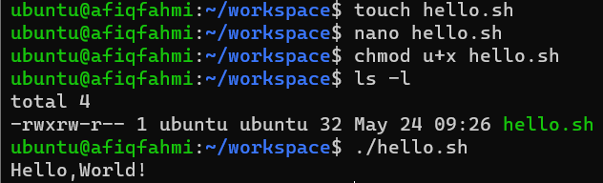

* 1. Using variable

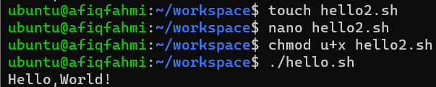

* 1. Using variable arithmetic

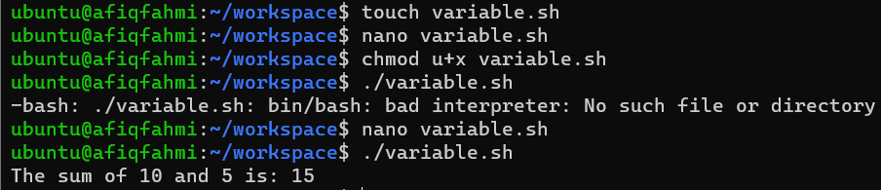

* 1. Getting User Input

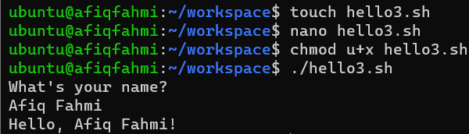

* 1. Getting User Input

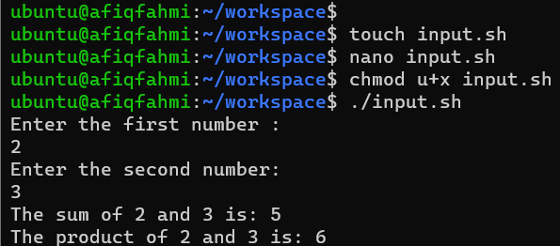

* 1. Conditional Statements

* 1. Loop

* 1. Running Several Linux Commands

* 1. Modify File Permissions

